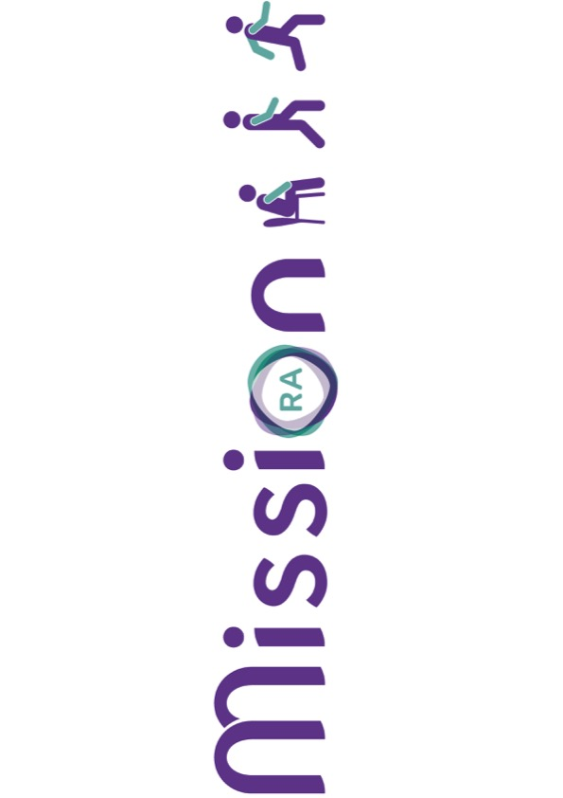
MISSION-RA

Participant Information Sheet

MovIng to Support Sustained Improvement of Outcomes iN Rheumatoid Arthritis (MISSION-RA)
V4.0 19/10/2023

Invitation and brief summary
Thank you for taking the time to read this information sheet. We would like to invite you to take part in our research study. Taking part is entirely up to you.

Before you decide we would like you to understand why we are doing this research and what it will involve. A member of our research team will go through this information sheet with you, to help you decide whether or not you would like to take part and to answer any questions you may have. Please feel free to talk to others about the study too if you wish.

This information sheet tells you the purpose of the study, what will happen if you take part, and detailed information about the conduct of the study. Please do take the opportunity to ask any questions you have and to ask for more information if anything is unclear.

Your participation in the study is entirely voluntary.

What is this research about?
Research tells us that physical activity is good for people living with Rheumatoid Arthritis (RA). However, people living with RA can find physical activity a challenge, due to symptoms such as joint pain or fatigue. Better support is needed to help people living with RA do more physical activity, and to stay physically active in the long-term.

We are going to develop a mobile phone app which can help people with RA be more physically active. The MISSION-RA app will link to a popular activity tracker - the Fitbit. Together, the app and the Fitbit will give personalised feedback on physical activity behaviour and suggest changes to help people with RA increase their physical activity and improve their health.

In total, over 100 people living with RA will help develop the MISSION-RA app. This will give enough information to make sure that the app is tailored to people with RA, to give them more personalised support to increase their physical activity, if they want and need to. In this part of the research, we are asking you to take part in a focus group or interview, where you will be asked about the factors that make you more or less likely to take part in physical activity. We will also ask about your use of activity trackers and mobile health apps.

Why have I been chosen?
We are asking you to take part in this study because you have a diagnosis of RA, are over 18 years old and can walk either independently or with the assistance of a walking aid.

What would taking part involve?
If you agree to take part in this study, you will be provided with a copy of this information leaflet. Once you have read through and have had the opportunity to discuss the study with a member of the research team, you will be asked to sign a consent form if you still wish to take part.

You do not need to agree to take part in the study immediately, and can have some time to think about whether or not you would like to participate. If you would like to take part in the study at a later date, you can do so by contacting the research team using the contact details at the end of the information sheet.

If you decide to take part: Before you can take part in the study, we will check your eligibility. With your permission, a member of the research team will ask your RA consultant to provide some information from your medical notes, based on your last hospital visit. This information is your:
- Height and weight
- Blood pressure
- Disease Activity Score-28

We will ask you to complete some questionnaires about your daily activities, your health, and your use of smartphones and activity trackers. This will help us describe the types of people who have helped develop the MISSION-RA app.

Will I be asked to take part in a focus groups or an interview?
When you have given your consent to take part in the research, we will ask you to take part in either a:
- focus group, or
- one-on-one interview with the researcher
- one-on-one interview with another person living with RA who has been identified as a patient-research partner through the National Rheumatoid Arthritis Society (NRAS), and has been trained in conducting interviews and focus groups.
Which type of interview or focus group you are asked to take part in, will depend on whether or not you took part in the first part of the MISSION-RA study. There is more information on this below (“where will I take part”). In the first part of the study, people living with RA wore activity trackers and a wearable camera for 48 hours. If you took part in the wearable camera and activity tracker part of MISSION-RA, you will be asked to have a one-on-one interview with the researcher. If you have not worn an activity tracker and wearable camera, you will be asked to join either an interview or a focus group with either the researcher, or a patient-research partner. If you are chosen to be interviewed by a patient-research partner, we will ask you if you are willing to do this before you provide your informed consent.

Where will I take part?
For both the focus groups and interviews we will ask if you would rather do this at 1) the hospital where you were recruited, 2) the National Rheumatoid Arthritis Society (NRAS) Headquarters (in Maidenhead) or 3) the University of Birmingham. If you are taking part in a one-on-one interview, we may also be able to do this at your own home, if you prefer. Due to the COVID-19 pandemic, we may also hold focus groups and interviews online. If you would feel most comfortable with an online focus group or interview, please let a member of the research team know. The information that will be asked during the focus groups and interviews is described below.

Focus groups:
If you are asked to take part in a focus group, you will do this with another 5-6 people living with RA. We will ask you about the things which help you to be more physically active. We will also ask about things which may get in the way of being physically active. We are also interested in hearing your views on activity trackers (such as the Fitbit) and mobile health apps, to learn about how and why you may use these types of technology. If you do not use these types of technology, we are also interested in understanding why this is, and the things which may make you more likely to do so. The focus group will take between 1 and 1.5 hours.

Interviews:
If you are asked to take part in an interview, this will be one-on-one with the researcher or a patient-research partner. The interview will ask general questions about your experiences of physical activity living with RA. You may also be asked about your views on everyday use of activity trackers (e.g. Fitbit, Apple watch) and mobile health apps. This will help us to understand if you use these types of technology, and the things which make you more or less likely to do so. The interview will take about 1 hour.

Note: If you took part in the first part of the MISSION-RA study, the researcher will talk through the data you recorded when you wore the camera and activity trackers. Using this data, you will then be asked questions to try and better understand the things that made you more or less likely to do different type of physical activity. We will also ask you about your experience of wearing the camera and activity trackers, to see if we can learn from this for future research.

Recording of focus groups and interviews: Both the focus groups and interviews will be recorded using a video camera. This is so we have a record of what was said, and so that we know who was saying what (for focus groups). Video recordings also help us to understand the context of what a person is saying in a more detail. We will ask your consent for the focus groups and interviews to be recorded and transcribed (written into a document, word for word), when you agree to take part in the study.

What are the possible benefits of taking part?
This information will be used to develop an intervention (the MISSION-RA app) which may be made available through the NHS, with the aim of improving the longer-term care for people with RA.

What are the possible disadvantages/risks of taking part?
This study should not have any effects on your everyday life. Due to COVID-19, we can conduct focus groups and interviews online depending on government guidance and social distancing measures. Please let a member of the research team know if you would prefer an online focus group or interview.

Who is organising and funding the research?
This research is being funded by the National Institute for Health Research (NIHR), and carried out by Dr Sally Fenton. The University of Birmingham Clinical Trials Unit (BCTU) are helping to organise the study. The study Sponsor is the University of Birmingham, which means the University has certain legal and ethical responsibilities for the study. The data controller is the University of Birmingham. This means the University is responsible for looking after your information and using it properly.

How have patients and the public been involved in this study?
A group of people living with RA have helped to develop this research topic, and to decide on the inclusion and exclusion criteria for people taking part. People living with RA have/will also:
- reviewed the study procedures and this information sheet, to help make sure what we are asking patients to do is acceptable for people with RA
- been recruited as patient-research partners to help conduct the interviews and focus groups, and support the research team to analyse the data
- help the research team design the MISSION-RA app that we will produce using this research

Who has reviewed the study?
All research in the NHS is looked at by an independent group of people, called a Research Ethics Committee (REC), to protect your interests. This study has been reviewed and given a favourable opinion by the Queen Square Research Ethics Committee.

Involvement of your Healthcare providers
The Rheumatology department at the hospital where you receive your care may know you are participating in this study. They will be asked to allow us to look at your medical notes so that we can record information on your height, weight, blood pressure and Disease Activity Score-28 (as described in Section 4 above). Your GP will not be informed that you are participating in this study.

How will we use information about you?
We will need to use information collected from you and your medical records for this research project. This information will include your;
- name
- date of birth
- gender
- age
- ethnicity
- post-code
- data from your medical notes (described in part 4 above)
- your e-mail address and/or telephone number
People will use this information to do the research or to check your records to make sure that the research is being done properly. People who do not need to know who you are will not be able to see your name or contact details. Your data will have a unique study ID number instead. We will keep all information about you safe and secure.
Once we have finished the study, we will keep some of the data so we can check the results. We will write our reports in a way that no-one can work out that you took part in the study.

- What are your choices about how your information is used?
You can stop being part of the study at any time, without giving a reason, but we will keep information about you that we already have.

- Where can you find out more about how your information is used?
You can find out more about how we use your information:
- at www.hra.nhs.uk/information-about-patients/
- The Health Research Authority leaflet, available at www.hra.nhs.uk/patientdataandresearch
- by asking one of the research team
- by sending an email to s.a.m.fenton@bham.ac.uk
- by ringing us on 07964000182
- from the University of Birmingham Data Protection Office: Email: dataprotection@contacts.bham.ac.uk. Telephone: 0121 414 3916

- What will happen to the data I give?
All focus groups and interviews will be recorded on a video camera, and data will be immediately downloaded onto a secure server at the University of Birmingham. Your study ID or a generic file name (e.g. Focus group 1) will be used to ensure your data remains anonymous, and files can only be accessed by members of the research team.

The anonymised files will then be transferred to a third party (external company) who will transcribe (write, word for word) the audio and visual data into a written document for analysis. We will ensure we use a secure system to transfer your data, and that the third party removes any of your personal data (e.g. your name) when it is transferred into the written document. The third party will then transfer the written documents back to the research team using a secure system. The third party who will be used to analyse this data will act on behalf of the University of Birmingham, and must follow our rules about keeping your information safe. We make sure we have appropriate contracts in place with them to protect and safeguard your data.

If we have conducted your focus group or interview online (e.g. via ZOOM), we will do this through a University of Birmingham account, which is secure and encrypted.

For the purposes of this study, we may also need to share your anonymised data with collaborators at the Universities of Oxford, Bristol and Southampton and Loughborough University, so that they can help to analyse the data. We have appropriate agreements in place with them to protect and safeguard your data.

How long will my data be kept? All data will be kept for 10 years after the end of the study. Only members of the research team and Birmingham Clinical Trials Unit staff will have access to this data archive.

What if something goes wrong?
If you have a concern about any aspect of this study, you should ask to speak to the Chief Investigator, Dr Sally Fenton, who will do her best to answer your questions (Email: s.a.m.fenton@bham.ac.uk, Tel: 07964 000182).

If you were approached to take part in the study at the hospital where you receive your care, and you wish to complain formally, you can do this by contacting the Patient Advice and Liaison Service (PALS) at your hospital (see Contact Information at the end of this information sheet).

Will my travel expenses be reimbursed?
Yes, you will receive up to £15 to reimburse your travel expenses if you travel to the hospital site or the University of Birmingham to take part in the focus group or interview. If you take part in interviews at NRAS Headquarters in Maidenhead, we will reimburse the cost of fuel from your home address, or the cost of your return train ticket. We will also provide refreshments during interviews and focus groups.

What happens when the study stops?
At the end of your participation in the study (after your interview or focus group), your Rheumatologist will continue to look after you and your treatment.

What will happen to the results of the study?
The results of the study will be published and a final report written. Data may also be presented at scientific meetings.

Do you have any further questions?
If you require further information about the study, then please contact the Chief Investigator (Dr Sally Fenton, contact information is on the next page). If you were approached about this study at the hospital where you receive your care, you can also speak to your Rheumatology consultant if you have questions about whether or not you should participate.

To find more information about the MISSION-RA study on the MISSION-RA website at www.mission-ra.co.uk and the twitter account @MISSION_RA. You can find out more information about how physical activity can help people living with RA, through the National Rheumatoid Arthritis Society at https://nras.org.uk/resource/exercise-and-rheumatoid-arthritis/

Contact Information

Dr Sally Fenton
Lecturer in Lifestyle Behaviour Change
University of Birmingham
MISSION-RA Chief Investigator
E-mail: s.a.m.fenton@bham.a.uk
Tel: 07964 000182

